How to Keep your Recruiting Process Progressing During COVID-19

by Alison Foley: author of The Elusive Full-Ride Scholarship: An Insider’s Guide

- Communication:
Continue to email college coaches any academic updates. Let them know what you have been doing athletically to improve your skills or fitness level. See if you can get on virtual talk and hear from their current team members. See if you can set up a virtual meeting with the coaching staff and utilize it like it is an unofficial visit.

- Academics:
Utilize this time to do more research on specific majors and academic programs offered at the school. Many schools are offering virtual tours, virtual college fairs, and one on one meetings with an academic counselor or an alum.

- Standardized Testing and Financial Aid:
Do some extra SAT or ACT preparation. Take more practice exams and continue to keep an eye on new testing dates that are being offered. Investigate financial aid options. Sign up to get the schools email updates.

- Film:
Send coaches game film of you. It is a good time to create a highlight reel of yourself excelling in sports. Also, create a skills tape and show what you have been doing through COVID-19 to keep your skills sharp. Many coaches have film of their team’s competition on-line that you can watch. This is also a great way to show your interest in the program when you communicate with the coaches.

- Recommendations:
Ask your club or high school coach to email a letter of recommendation or to make a call on your behalf to the college coaches. Ask an advisor, teacher, employer if they could write a character reference for you. If you have attended a camp or clinic in the past year and received an evaluation you can send that to the college coaches.

In their new book, The Elusive Full Ride Scholarship: An Insider's Guide, authors Mia Wenjen and Alison Foley break down the daunting college recruitment process into a step-by-step strategy over the four years of high school.
The Elusive Full Ride Scholarship: An Insider's Guide was written to help high school coaches, athletes, and parents navigate college sports recruiting to find the right fit. It covers many crucial topics including recruiting Do's & Don'ts; ways to communicate with coaches, teams, and schools; how academics play into the recruiting process; how to build a recruitment kit; the role parents' play, and much more. This guide reveals insider tips from athletes and college coaches share their advice to high school students.
Use this book as a game plan to navigate the recruiting and scholarship process successfully – and with minimum stress.
About Alison Foley (co-author of The Elusive Full-Ride Scholarship and How to Coach Girls).
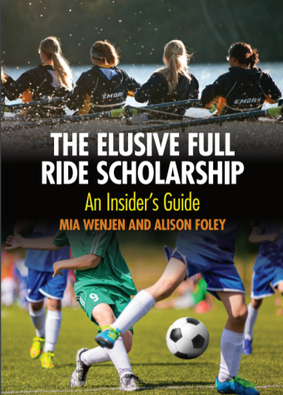
Foley is Boston College's former Women's Soccer Head Coach and was the college's winningest coach with more than 260 wins. Foley led her team to 15 NCAA tournament appearances, eight Sweet 16’s Appearances, three Elite Eight appearance, and one NCAA Final Four and Final Eight during thirteen consecutive playoff appearances. She is currently the founder of Foley Athletic Advising, which provides expertise in the college recruiting process for student-athletes who aspire to play in college.

